

**MINI -PROJECT report:**

**PAYROLL MANAGEMENT SYSTEM USING C++**

**( B.Tech-Cse)**

**PRIYANSHI KAMBOJ**

**2016928**

**3RD SEMESTER**

**ACKNOWLEDGEMENT:**

Here by I, ‘PRIYANSHI KAMBOJ’ , am submitting the project report on **“PAYROLL MANAGEMENT SYSTEM USING C++”** as per the scheme of Graphic Era Deemed University, Dehradun.

I would also like to express my gratitude to my mentor Mr. Kireet Joshi sir and all the faculty members of the computer science department for their constant encouragements and much needed support for the successful completion of the project.

Finally I am very much thankful to all , friends and my parents for their constant encouragement, support and help throughout the period of project conduction.

* **PROBLEM STATEMENT:-**

Design a payroll management system using c++.

* **MOTIVATION FOR DOING THE PROJECT:-**

Payroll manage system in c++ is a console application done with the use of object oriented programming with the use of graphics. Payroll management system is basically a program which provides financial solutions for any particular organization.  Payroll management helps account to maintain all records on using predefined rules set by on the organization working pattern. The main reason why I chose payroll as my project was that, it is possible for smaller businesses to handle payroll duties in-house through a manual process, much time can be wasted while attempting to calculate everything correctly. One miscalculation and the business owner could find themselves in legal or financial trouble. Payroll system eliminates the chance of mistakes while letting you calculate appropriate deductions and payments. Also it is faster thus, SAVES TIME and Payroll software often requires very little input wage information. Most payroll softwares are automatically updated whenever a tax flaw change and will remind employers when to file various tax forms.

* **OBJECTIVES**

Payroll Management System gives you the power to:

* Manage Employee Information efficiently.
* Define the earnings, deductions, leave etc.
* Generate Pay-Slip at the convenience by a click.
* Generate and Manage the Payroll according to the Salary Structure assigned to the employee
* **SYSTEM ARCHITECTURE :-**

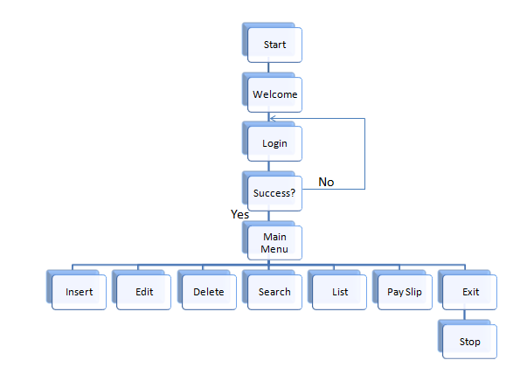

* **MODULES :-**

1. **Admin Login Module:** Here in this module call, user is required to enter the login details. The Login Module is a portal that allows users to type a user name and password to login.
2. **Data Entry Module:** After you selected data entry from the main menu you land on this screen. In this module, Data of the employee are inserted.
3. **Storing and Retrieving Data Records Module: R**ecords of all the employees are to be maintained and the records are stored in Files and the information is retrieved from the files.

* **TECHNOLOGIES USED :-**
* **C++ :-**

C++ is a high-level language that has developed in mid of 1970’s. It is built or derived from C language. It has object oriented features which allows programmer to create objects within the code. C++ is a general purpose programming language and widely used now a days for competitive programming. It has imperative, object-oriented and generic programming features. C++ runs on lots of platform like Windows, Linux, Unix, Mac etc.

* **C++ Classes and Objects:-**
* **Class:-**

The building block of C++ that leads to Object Oriented programming is a Class. It is a user defined data type, which holds its own data members and member functions, which can be accessed and used by creating an instance of that class. A class is like a blueprint for an object.

* **Object:-**

**Object** is an instance of a Class. When a class is defined, no memory is allocated but when it is instantiated (i.e. an object is created) memory is allocated.

* **C++ FUNCTIONS :-**

A function is a group of statements that together perform a task. Every C++ program has at least one function, which is **main()**, and all the most trivial programs can define additional functions. A C++ function definition consists of a function header and a function body.

* **FILE HANDLING IN C++:-**
* **Opening a File:-**

A file must be opened before you can read from it or write to it. Either **ofstream** or **fstream** object may be used to open a file for writing. And ifstream object is used to open a file for reading purpose only.

* **Closing a File:-**

When a C++ program terminates it automatically flushes all the streams, release all the allocated memory and close all the opened files. But it is always a good practice that a programmer should close all the opened files before program termination.

* **Writing to a File:-**

While doing C++ programming, you write information to a file from your program using the stream insertion operator (<<) just as you use that operator to output information to the screen.

* **Reading from a File:-**

You read information from a file into your program using the stream extraction operator (>>) just as you use that operator to input information from the keyboard.

* **Code for main function:-**

int main()

{

setWindowSize();

border();

intro();

loading();

loginFrame();

login();

menu();

getrecords();

char option;

if(emp[0].code==0 && isFilePresent())

num--;

while(1)

{option=getch();

switch(option)

{

case 'l':

list();

break;

case 'i':

insert();

break;

case 'd':

deletes();

break;

case 'e':

edit();

break;

case 's':

search();

break;

case 'p':

displayPayslip();

break;

case 'q':

saverecords();

exit(0);

}

menu();

}

return 0;

}

* **MAIN FUNCTION ON CONSOLE:-**

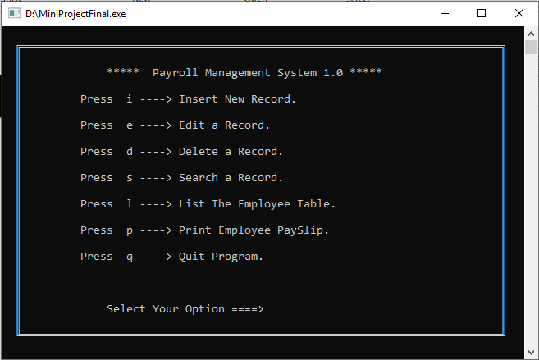

* **CONCLUSION :-**

The delivered system “PAYROLL MANAGEMENT SYSTEM” software has been designed to achieve maximum efficiency and reduce the time taken to handle the payroll activity. It is designed to replace an existing manual record system thereby reducing time taken for calculations and for storing data.

The system is strong enough to withstand regressive daily operations under conditions where the data is cleaned over a certain time of span. The implementation of the system in the organization will considerably reduce data entry, time and also provide readily calculated reports. The System has adequate scope for modification in future if it is necessary.